Resource availability and disturbance shape maximum tree height across the Amazon

*Tall trees are key drivers of ecosystem processes in tropical forest, but the controls on the distribution of the very tallest trees remain poorly understood. The recent discovery of grove of trees over 80 meters tall in the Amazon forest requires a reevaluation of current thinking. We used high-resolution airborne laser surveys to measure canopy height across 282,750 ha of old-growth and second growth forests randomly sampling the entire Brazilian Amazon. We investigated how resources and disturbances shape the maximum height distribution across the Brazilian Amazon through the relations between the occurrence of giant trees and environmental factors. Common drivers of height development are fundamentally different from those influencing the occurrence of giant trees. We found that changes in wind and light availability drive giant tree distribution as much as precipitation and temperature, together shaping the forest structure of the Brazilian Amazon. The location of giant trees should be carefully considered by policy-makers when identifying important hotspots for the conservation of biodiversity in the Amazon.*

# Introduction

The Amazon is the largest tropical forest on Earth, covering 5.5 million square kilometers, and storing ~ 17% of all vegetation carbon. Ecologists have long taken an interest in comparing forest structure across the tropics (Yang et al., 2016), and have reached a consensus that the Amazon supports shorter trees, and therefore stores a lower amount of carbon per hectare, than the forests of tropical Africa and Asia (Cao & Woodward, 1998; Feldpausch et al., 2012). Previous studies have shown the occurrence of tall canopy regions in the Amazon and debated the factors that govern Amazon tree growth (Lefsky 2010; Simard et al., 2011; Larjavaara, 2013; Tao et al., 2016a). However, the recent confirmation of the existence of giant trees - up to 88 m tall - in the Amazon basin (Gorgens et al., 2019) challenges some paradigms and poses new questions about the drivers causing the spatial distribution of tall trees, and consequently about how maximum tree height is shaped across different regions.

To reach such immense size, trees must fulfill at least three conditions:  They must (1) have evolved to be capable of transporting water to great heights overcoming highly negative water potentials (Koch et al., 2004; Niklas, 2007; McDowell et al., 2008);  (2) inhabit an area with environmental conditions (such as climate, soil properties, and water) that meet species-specific requirements (Simard et al., 2018; Scheffer et al., 2018) and (3) grow in regions with a low frequency of natural or anthropogenic disturbance events (Larjavaara, 2013; Lindenmayer & Laurance, 2016; Scheffer et al., 2018; Enquist et al., 2020).

Height growth is partly governed by local factors such as water availability, temperature, rooting depth, and soil type (Anderegg et al., 2016; McDowell & Allen, 2015; Coomes et al., 2006; Niklas, 2007), with precipitation and potential evapotranspiration consistently reported as key factors determining plant height across biomes (Moles et al., 2009; Larjavaara, 2013; Rueda et al., 2016). Resource availability (e.g. sunlight, nutrients, CO2, and water) controls a tree’s ability to produce biomass from the products of photosynthesis. In contrast, natural disturbances (e.g. wind-throw, drought, or lightning and anthropogenic actions (e.g. selective logging, forest fragmentation) increase the likelihood of mortality and limit the time available for trees to grow taller (Bennett et al., 2015; Yanoviak et al., 2019; Almeida et al., 2019; Powers et al., 2020). Tall trees are likely to have developed strategies for surviving diseases and pathogens (van Gelder et al., 2006; Aleixo et al., 2019) as well as climatic fluctuations (Sakschewski et al., 2016) and resisting wind damage (Jagels et al., 2018).

The sheer size of the Amazon, its environmental heterogeneity and species diversity, pose challenges and practical difficulties to understand general ecological relationships and biogeographical patterns (Tuomisto et al., 2019). Forest plots provide many valuable insights to investigate the influences of the environment on tree height but they can only represent a minuscule fraction of the total forest area (Chave et al., 2020). Currently, a network of 5,351 forest inventory plots established across the Brazilian Amazon, of known and published sites recently compiled by (Tejada et al., 2019), represents only 0.0013% of the total forest area in this region. In addition, the plot distribution is spatially clustered in close proximity to major roads or large rivers (Stropp et al., 2020), implying a spatial distribution bias (Marvin et al., 2014) because about 42% of the total Brazilian Amazon lies over 50 km from the nearest forest inventory plots (Tejada et al., 2019). Remote sensing can remove sampling biases and uncertainty about ecological patterns (Schimel et al., 2015) and provides large datasets to uncover the environmental controls of forest structure (Asner et al., 2010). In particular airborne LiDAR  (Light Detection and Ranging) generates valuable high-resolution 3D information of forest canopy structure (Görgens et al., 2016; Coomes et al., 2017), and can provide a link between field and satellite data (Asner, 2009; Bae et al., 2019).

The question of how resources and disturbances determine maximum tree height across the Amazon has not been fully explored. In this study, we employed the largest airborne LiDAR data collection in the Amazon to contribute to the understanding of (1) how resources and disturbances shape the maximum height distribution across the Brazilian Amazon, and (2) what drives the occurrence of giant trees (taller than 70 meters). We conducted an extensive analysis relating remotely sensed environmental variables to the maximum height recorded in the transects.

# Methods

Between 2016 and 2018, an airborne mission (held by National Institute for Space Research - INPE and funded by Amazon Fund) collected airborne LiDAR data from 906 transects of 375 ha (12.5 x 0.3 km) each. Most of them were randomly spread across old-growth and second growth forests defined by the PRODES database - layer mask of old-growth forests (**PRODES, INPE**, 2016) and by the TerraClass database - a layer mask of second growth forest (**TerraClass, INPE**, 2014). Few transects were intentionally overlap to field plots to allow model biomass calibration. Details about LiDAR parameterization, processing, and the EBA project characteristics can be consulted in the supplementary material from Gorgens et al. (2019). Briefly, the average pulse density was 4 pulses m−2, the field of view equal to 30°, and flying altitude of 600 m. The pulse footprint was set to be below 30 cm, based on a divergence angle between 0.1 and 0.3 mrad. Each transect was processed by identifying the returns from the ground and interpolating a 1m spatial resolution digital terrain model (DTM) from them. Then, the DTM was employed to calculate the heights above ground from the returns from vegetation. The uppermost vegetation heights were then employed to compute a canopy height model CHM at the same spatial resolution as the DTM. While errors in estimation of terrain height can affect tree height estimations, previous studies in tropical forests show that LiDAR surveys with at least 4 returns per m2 have high penetration through the canopy permitting accurate DTM generation and tree height estimation (Clark et al., 2004; Glenn et al., 2011; Leitold et al. 2015; Andrade et al., 2018).

A forest consists of superimposed groups of plants that occur in different combinations over the landscape, and each individual is sensitive to certain aspects of the environment (Vanclay, 1992). The soil (fertility, drainage), climate (temperature and rainfall patterns), topography (altitude, aspect), and other factors can only give a general indication of site productivity because they fail to account for any local variations in the site (e.g. the species present) (Binkley et al., 2004). Site comparison, like we are proposing here, should prefer indicators not unduly influenced by stand condition, use history, or diversity complexity. Maximum stand height for sites that are sufficiently large to reflect the maximum height that the nominated species is likely to attain is a perfect indicator (Daubenmire, 1976). For the reasons above, a single tallest tree was identified, located and isolated per transect using an individual tree approach based on a local minimum filter. All the trees were manually inspected to not allow that maximas not related to trees influences in the analysis (Supplementary Figure 1)*.*

## Environmental variables

To investigate drivers influencing the spatial distribution of giant trees, we initially considered a total of 18 environmental variables: (1) fraction of absorbed photosynthetically active radiation (FAPAR; in %); (2) elevation above sea level (Elevation; in m);  (3) the component of the horizontal wind towards east, i.e. zonal velocity (u-speed ; in m s-1); (4) the component of the horizontal wind towards north, i.e. meridional velocity (v-speed ; in m s-1); (5) the number of days not affected by cloud cover (clear days; in days yr-1); (6) the number of days with precipitation above 20 mm (days > 20mm; in days yr-1 ); (7) the number of months with precipitation below 100 mm (months < 100mm; in months yr-1 ) ; (8) lightning frequency (flash rate); (9) annual precipitation (in mm); (10) annual potential evapotranspiration (in mm); (11) coefficient of variation of monthly precipitation (precipitation seasonality; in %); (12) amount of precipitation on the wettest month (precip. wettest; in mm); (13) amount of precipitation on the driest month (precip. driest; in mm); (14) mean annual temperature (in °C); (15)  standard deviation of monthly temperature (temp. seasonality; in °C); (16) annual maximum temperature (in °C); (17) soil clay content (in %); and (18) soil water content (in %).   Data sources are described in the following paragraphs and listed in Table 1.

The FAPAR was derived from land surface reflectance product calibrated and corrected from the National Oceanic and Atmospheric Administration’s (NOAA) Advanced Very High-Resolution Radiometer (AVHRR), which is a consistent time-series dataset spanning from the mid-1980s to present and suitable for climate studies (Tao et al., 2016b). FAPAR is a primary vegetation variable controlling the photosynthetic activity of plants and is considered an essential climate variable (Mason et al., 2010).

The elevation was based on the third version of the Shuttle Radar Topography Mission (SRTM) provided by the National Aeronautics and Space Administration Jet Propulsion Lab (NASA JPL) (Farr et al., 2007; Liu et al., 2014). The SRTM mission collected data during ten days of operations, using two synthetic aperture radars: NASA’s C band system (5.6 cm wavelength) and an X band system by DLR (3.1 cm). C-band partially penetrates the vegetation canopy, with depth varying with vegetation structure. Because Amazonian vegetation is dense throughout, for the purposes of this study the C-band DEM is assumed to vary consistently with topography across the region.

We used the maximum daily mean wind speeds over the last 5 years from the fifth major global reanalysis (ERA5) produced by the European Centre for Medium-Range Weather Forecasts (ECMWF). The reanalysis combined model data with observations from across the world into a globally complete and consistent dataset (Olauson, 2018). Two wind velocities were considered: u-speed which is the zonal velocity (i.e. the component of the horizontal wind towards east), and v-speed which is the meridional velocity (i.e. the component of the horizontal wind towards north). These products are used extensively for modeling wind power both in academia and industry (Olauson, 2018; Albergel et al., 2019; Ramon et al., 2019).  Although the ERA5 wind product gives mean wind speeds, these are related to extreme wind speeds by a Weibull distribution (Takle & Brown, 1978; Seguro & Lambert, 2000), so long-term variation in mean wind speed will indicate variability and trends in extremes between regions. To compute the wind speed map, ERA5 does not ingest surface winds from land stations. As a result, ERA5 is parametrized in planetary boundary layer schemes from surface characteristics resulting in lowering the inland speed (Ramon et al., 2019).

The number of clear days was computed based on Moderate Resolution Imaging Spectroradiometer (MODIS) surface reflectance products. MODIS products provide an estimate of the surface spectral reflectance as it would be measured at ground level in the absence of atmospheric scattering or absorption (Kang et al., 2005; Bisht & Bras, 2010). We used the Terra MOD09GA Version 6 product, which provides an estimate of the surface spectral reflectance of MODIS, corrected for atmospheric conditions such as gases, aerosols, and Rayleigh scattering.

Temperature and precipitation were obtained from the WorldClim database of bioclimatic variables, which are derived from weather station data compiled for the 1950-2000 period (Hijmans et al., 2005; Fick & Hijmans, 2017). The main source of data was the Global Historical Climatology Network (GHCN), complemented with other global, national, regional, and local data sources, which were added if they were further than 5 km away from stations already included in the GHCN.

The lightning frequency was provided by Lightning Imaging Sensor (LIS) instrument onboard the Tropical Rainfall Measuring Mission provided by NASA Earth Observing System Data and Information System (EOSDIS) Global Hydrology Resource Center. The LIS provided the basis for the development of a comprehensive global thunderstorm and lightning climatology to detect the distribution and variability of total lightning occurring in the Earth (Albrecht et al., 2016).

The potential evapotranspiration was provided by the TerraClimate dataset, a global monthly climate and water balance for terrestrial surfaces spanning 1958–2015. The layer combined high-spatial-resolution climatological normals from WorldClim with Climate Research Unit (CRU) Ts4.0 and the Japanese 55-year Reanalysis (JRA-55) data. The Reference Evapotranspiration was calculated using the Penman-Monteith approach (Abatzoglou et al., 2018).

The number of months per year with precipitation below 100 mm and the number of days per year with precipitation above 20 mm was computed based on the Climate Hazards Group InfraRed Precipitation with Station data (CHIRPS) dataset. CHIRPS incorporated 0.05° resolution satellite imagery with in-situ station data to create gridded rainfall time series for trend analysis and seasonal drought monitoring (Funk et al., 2015).

Edaphic variables were obtained from The OpenLandMap produced by the OpenGeoHub Foundation and contributing organizations. The clay content (fine particles < 2 μm) and water content layers, both with a spatial resolution of 250 m, were created based on machine learning predictions from a global compilation of soil profiles and samples (Arsanjani et al., 2014).

To help visualization at the regional-level, we divided the Brazilian Amazon into eight regions, according to the classification of Morrone (2014). This regionalization is based on biogeographic analyses of terrestrial plant and animal taxa of the Neotropical region and seeks to provide universality, objectivity, and stability, such that it can be applied when describing distributional areas of particular taxa or comparing different biogeographic analyses (Morrone, 2014).

## Random Forest and Maximum Entropy

To explore the influence and importance of the environmental variables for development in tree height, we employed Random Forest modeling, an algorithm that generates a large number of regression trees, each constructed considering a random data subset (Breiman, 2001). The regression trees are used to identify the best sequence for splitting the solution space to estimate the output. To visualize how environmental variables relate to maximum height we used marginal plots, estimating the maximum height by one variable at a time, keeping other variables constant at an average value. Among the initial 18 environmental variables, two of them (precipitation of driest month and months < 100mm) were excluded due to high correlation (> 0.80) to other independent variables. Using the coordinates of the tallest tree within each LiDAR transect, we performed a simple extraction of the values for all variable layers. Tree height was then modeled against the factors using the random forest algorithm, which recursively computes classification and regression trees (CART) from random subsets, a k-fold (k = 15) cross-validation, using 500 as the number of CART. The number of variables randomly sampled as candidates at each split was set to 2. The adjusted model was evaluated considering the mean absolute error (MAE), root mean squared error (RMSE), and coefficient of determination (R²) of cross-validated predicted versus observed values. To assess the overall relative variable importance we used the mean increase in accuracy. The resulting Random Forest model was implemented to map estimated maximum tree heights across the Amazon.

Focusing only on the tallest trees - those over 70 m in height – we built an environmental envelope model to assess the conditions which allow them to occur. We employed the maximum entropy approach (MaxEnt) commonly applied to modelling species geographic distributions with presence-only data to discriminate suitable versus unsuitable areas for the species (Phillips et al., 2006). The variable importance of the MaxEnt model was used to indicate the most relevant characteristics associated with extremely tall individuals and the potential locations for new occurrence. In its optimization routine, the algorithm tracked how much the model gain was improved when small changes were made to each coefficient value associated with a particular variable.  Each variable was then ranked based on the proportion of all contributions. The resulting MaxEnt model was implemented using the environmental variables to deliver a map of probability of occurrence for trees taller than 70 m across the Amazon.

# Results

Trees exceeding 50 m were registered in 540 transects, widely distributed across many parts of the Brazilian Amazon. Within those transects, only 23 had trees above 70 m and only 6 registered trees above 80 m. The height distribution of the tallest individual trees selected for further analysis is presented in Fig. 1. The distribution of these tall trees is concentrated in the eastern Amazon in the Roraima and Guianan Lowlands biogeographic regions (Fig 2).

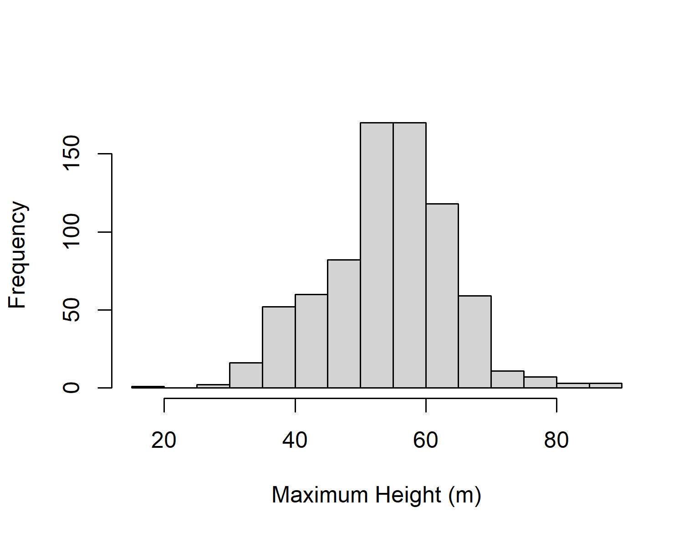

*Figure 1. Maximum tree height distribution of the 906 trees extracted from the 906 airborne lidar transects distributed across the Brazilian Amazon.*

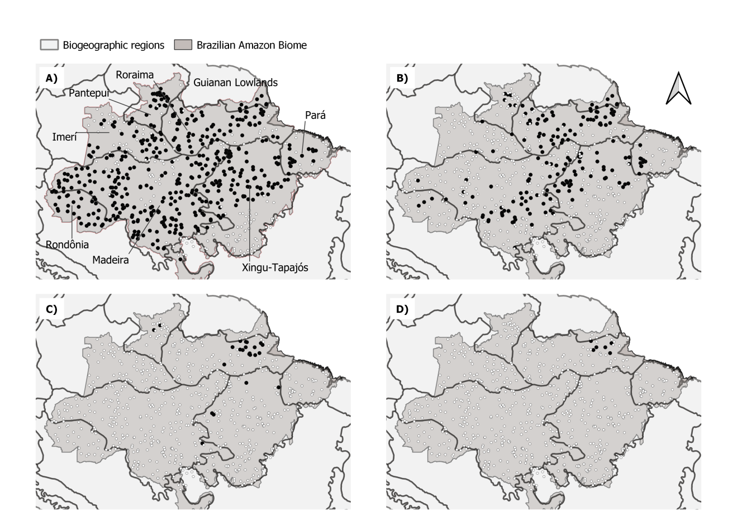

Figure 2. Maps of the Brazilian Amazon showing the location of transects considering height thresholds: 50 m, 60 m, 70 m, and 80 m in height. Black circles indicate transects with trees taller than the threshold, white circles indicate remaining transects.

The variables with the most explanatory power (based on increase in accuracy) in the Random Forests model were (1st) the number of clear days, followed by (2nd) clay content in the soil and (3rd) elevation. The difference between the 4th and the 15th positions of the importance rank was less than 6 units, ranging from 22.4 to 15.6. The variable soil water content (16th) was the weakest predictor (Table 1). Predictor variable importance could also be measured by an alternative metric node purity that generally correlated with the increase in accuracy (Supplementary Figure 2).

Table 1. Variables used to estimate maximum height distribution and evaluate its distribution, ranked by variable importance results in the Random Forest model

|  |  |  |  |  |  |  |  |
| --- | --- | --- | --- | --- | --- | --- | --- |
| Layer | Definition | Related to | Unit | Source | Spatial resolution (Time interval) | Expected influence in max. height | Importance  (increase accuracy) |
| clearDays | number of clear days per year | energy balance - water balance - radiation | Days | MODIS | 500 meters  (2014 - 2018) | Positive | 25.5 |
| clayContent | fraction of clay content | soil structure - physical properties - water availability | % | OpenLandMap | 250 meters | Positive | 23.4 |
| topography | elevation above sea level | distance to water - flooding zones - soil | M | SRTM | 30 meters | Positive | 23.3 |
| pannual | average annual precipitation | precipitation - precipitation intensity - precipitation distribution | Mm | WorldClim | 30 arc seconds | Positive | 22.4 |
| pseason | precipitation seasonality | precipitation - precipitation intensity - precipitation distribution | Mm | WorldClim | 30 arc seconds | Positive | 21.3 |
| tseason | temperature seasonality | temperature - temperature distribution | C | WorldClim | 30 arc seconds | Negative | 21.3 |
| uspeed | zonal speed (W-E) | storms - convective winds | m/s | ECM-RWF | 0.25 degrees  (2014-2018) | Negative | 21.1 |
| pet | potential evapotranspiration | energy balance - water balance - radiation - vegetation health - anthropic regions - soil exposure | Mm | TerraClimate | 2.5 arc minutes  (1990 - 2016) | Positive | 20.2 |
| fapar | fraction of absorbed photosynthetically active radiation | radiation - vegetation health - anthropic regions - soil exposure | % | NOAA AVHRR | 0.05 degrees  (2016 - 2018) | Positive | 20.0 |
| pwettest | precipitation of the wettest month | precipitation - precipitation intensity - precipitation distribution | Mm | WorldClim | 30 arc seconds | Negative | 19.9 |
| tmax | maximum temperatura | storms - convective winds | C | WorldClim | 30 arc seconds | Negative | 19.8 |
| vspeed | meridional speed (N-S) | storms - convective winds | m/s | ECM-RWF | 0.25 degrees  (2014-2018) | Negative | 18.1 |
| lightning | lightining rate | storms - convective winds | flashes rate | LIS TRMM | 0.1 degrees  (1998 - 2018) | Negative | 18.0 |
| days20 | days with precipitasion higher then 20 mm | storms - convective winds - precipitation | Days | CHIRPS | 0.05 degrees  (2014-2018) | Negative | 16.4 |
| tannual | daily average annual temperature | temperature - temperature distribution | C | WorldClim | 30 arc seconds | Negative | 15.6 |
| waterContent | fraction of water content | soil structure - physical properties - water availability | % | OpenLandMap | 250 meters | Positive | 9.7 |
| month100 | month with precipitation below 100 mm | precipitation - precipitation intensity - precipitation distribution | Months | CHIRPS | 0.05 degrees  (2014-2018) | Negative | Removed by high correlation |
| pdriest | precipitation of the driest month | precipitation - precipitation intensity - precipitation distribution | Mm | WorldClim | 30 arc seconds | Positive | Removed by high correlation |

The Random Forest model obtained MAE = 3.62 m, RMSE  = 4.92 m, and R² = 0.735 (observed versus predicted height plot is available in Supplementary Figure 3).  Mapped across the Brazilian Amazon the model predicted maximum tree height above 70 meters in 56,747 km² (1.03% of the area). Those regions are concentrated in the Eastern Amazon, with trees achieving the greatest heights in the Northeastern part of Roraima biogeographic region (Fig. 3).

The LiDAR sampling design included old-growth, degraded and second-growth forests often mixed in the same transect. Given the difficulties to accurately detect the boundaries between forest, we modeled all transects including second-growth and degraded forests. Then we repeated the Random Forest modeling after removing low values of FAPAR (< 80%) that are associated with degraded forests and anthropogenic regions - eliminating 133 transects. The spatial distributions for maximum tree height persisted after removing these potential anthropogenic effects. Variable importance was also similar and consistent (Supplementary Table 1).

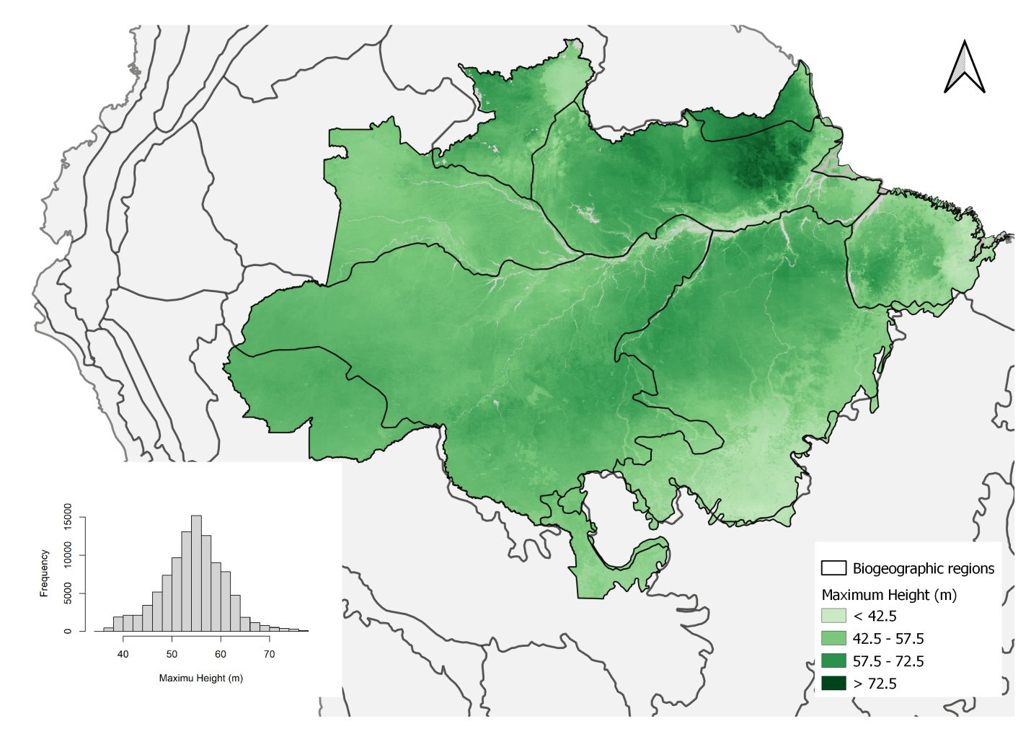

Figure 3. The maximum tree height distribution estimated by the Random Forest model based on the environmental variables. The map is available at https://doi.org/10.5281/zenodo.4036988.

The number of clear days was the strongest predictor of maximum height (Table 1). The shape of this relation resembles a step function (Fig. 4), in which regions with the number of clear days below 130 days per year support tall trees, with an abrupt decline in maximum height above this level. An increase in soil clay content from 20% to 40% translated into a 7 m increase in maximum height.  Elevation was also a key predictor of tree height, with low-lying forests growing 7 m lower than trees in terrains above 40 m above sea level.  Our results also demonstrate that mean annual precipitation was a key factor related to maximum height, with a tolerance curve peaking at around 2,300 mm yr-1 as optimal annual precipitation across the Brazilian Amazon. In comparison to these areas, we observe a 4 m decline in maximum tree height in regions with annual precipitation below 1,500 mm yr-1 or above 3,000 mm yr-1. From the intermediate importance variables, we highlight the zonal velocity (u-speed) and FAPAR influencing height variation in ranges around 6 m.

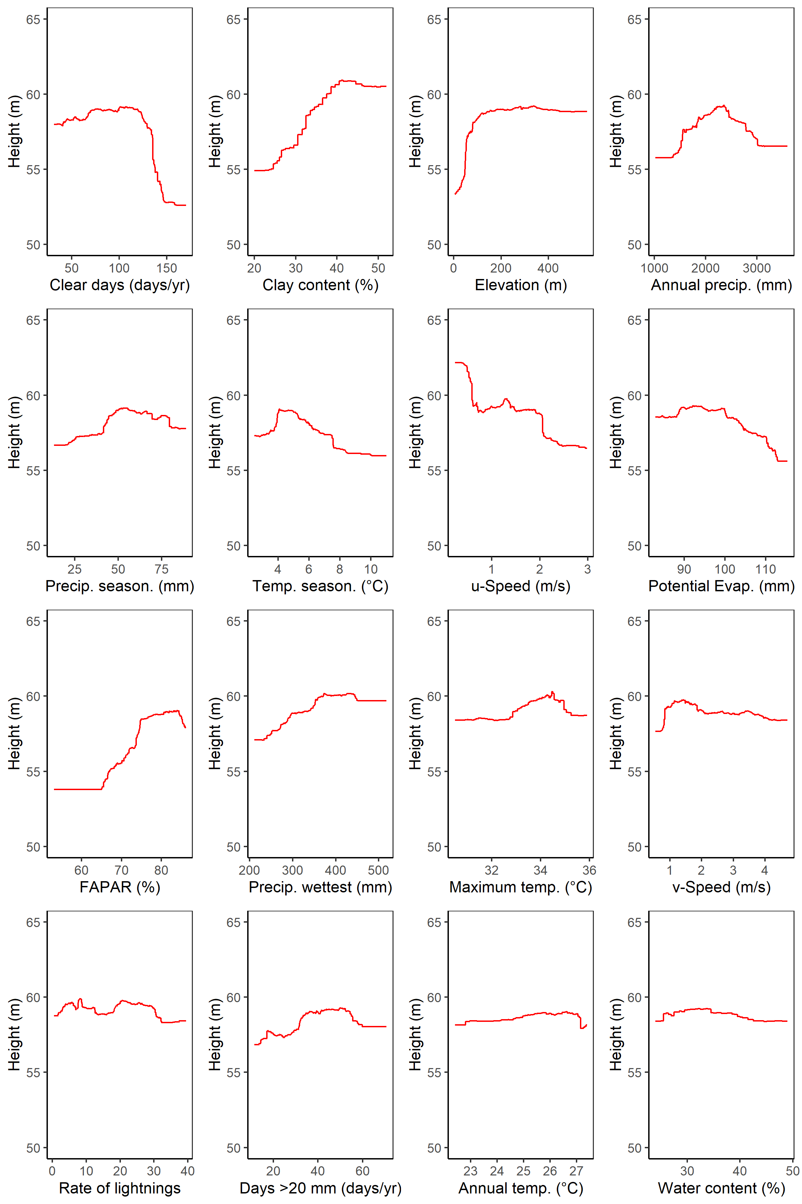

Figure 4. The marginal plot obtained for each environmental variable in the random forest model, keeping others constant on the average.

The results of the MaxEnt model focus on the occurrence of trees taller than 70 m in height. The extraordinarily tall trees were found in conditions characterized by a much smaller set of environmental variables from those which drove the large-scale patterns of maximum height (Fig. 5). The maximum entropy model shows that the occurrence is dominated mostly by wind speed (relative importance of 67.7 %). The second most important driver of tall tree occurrence was the elevation above sea level (relative importance of 12.3 %). The resulting map of predicted occurrence of the tallest trees in the Amazon from the MaxEnt model shows that the probability of maximum tree height occurrence is highest in northeastern Amazon (Fig. 6), more specifically in the Roraima and Guianan Lowlands biogeographic regions.

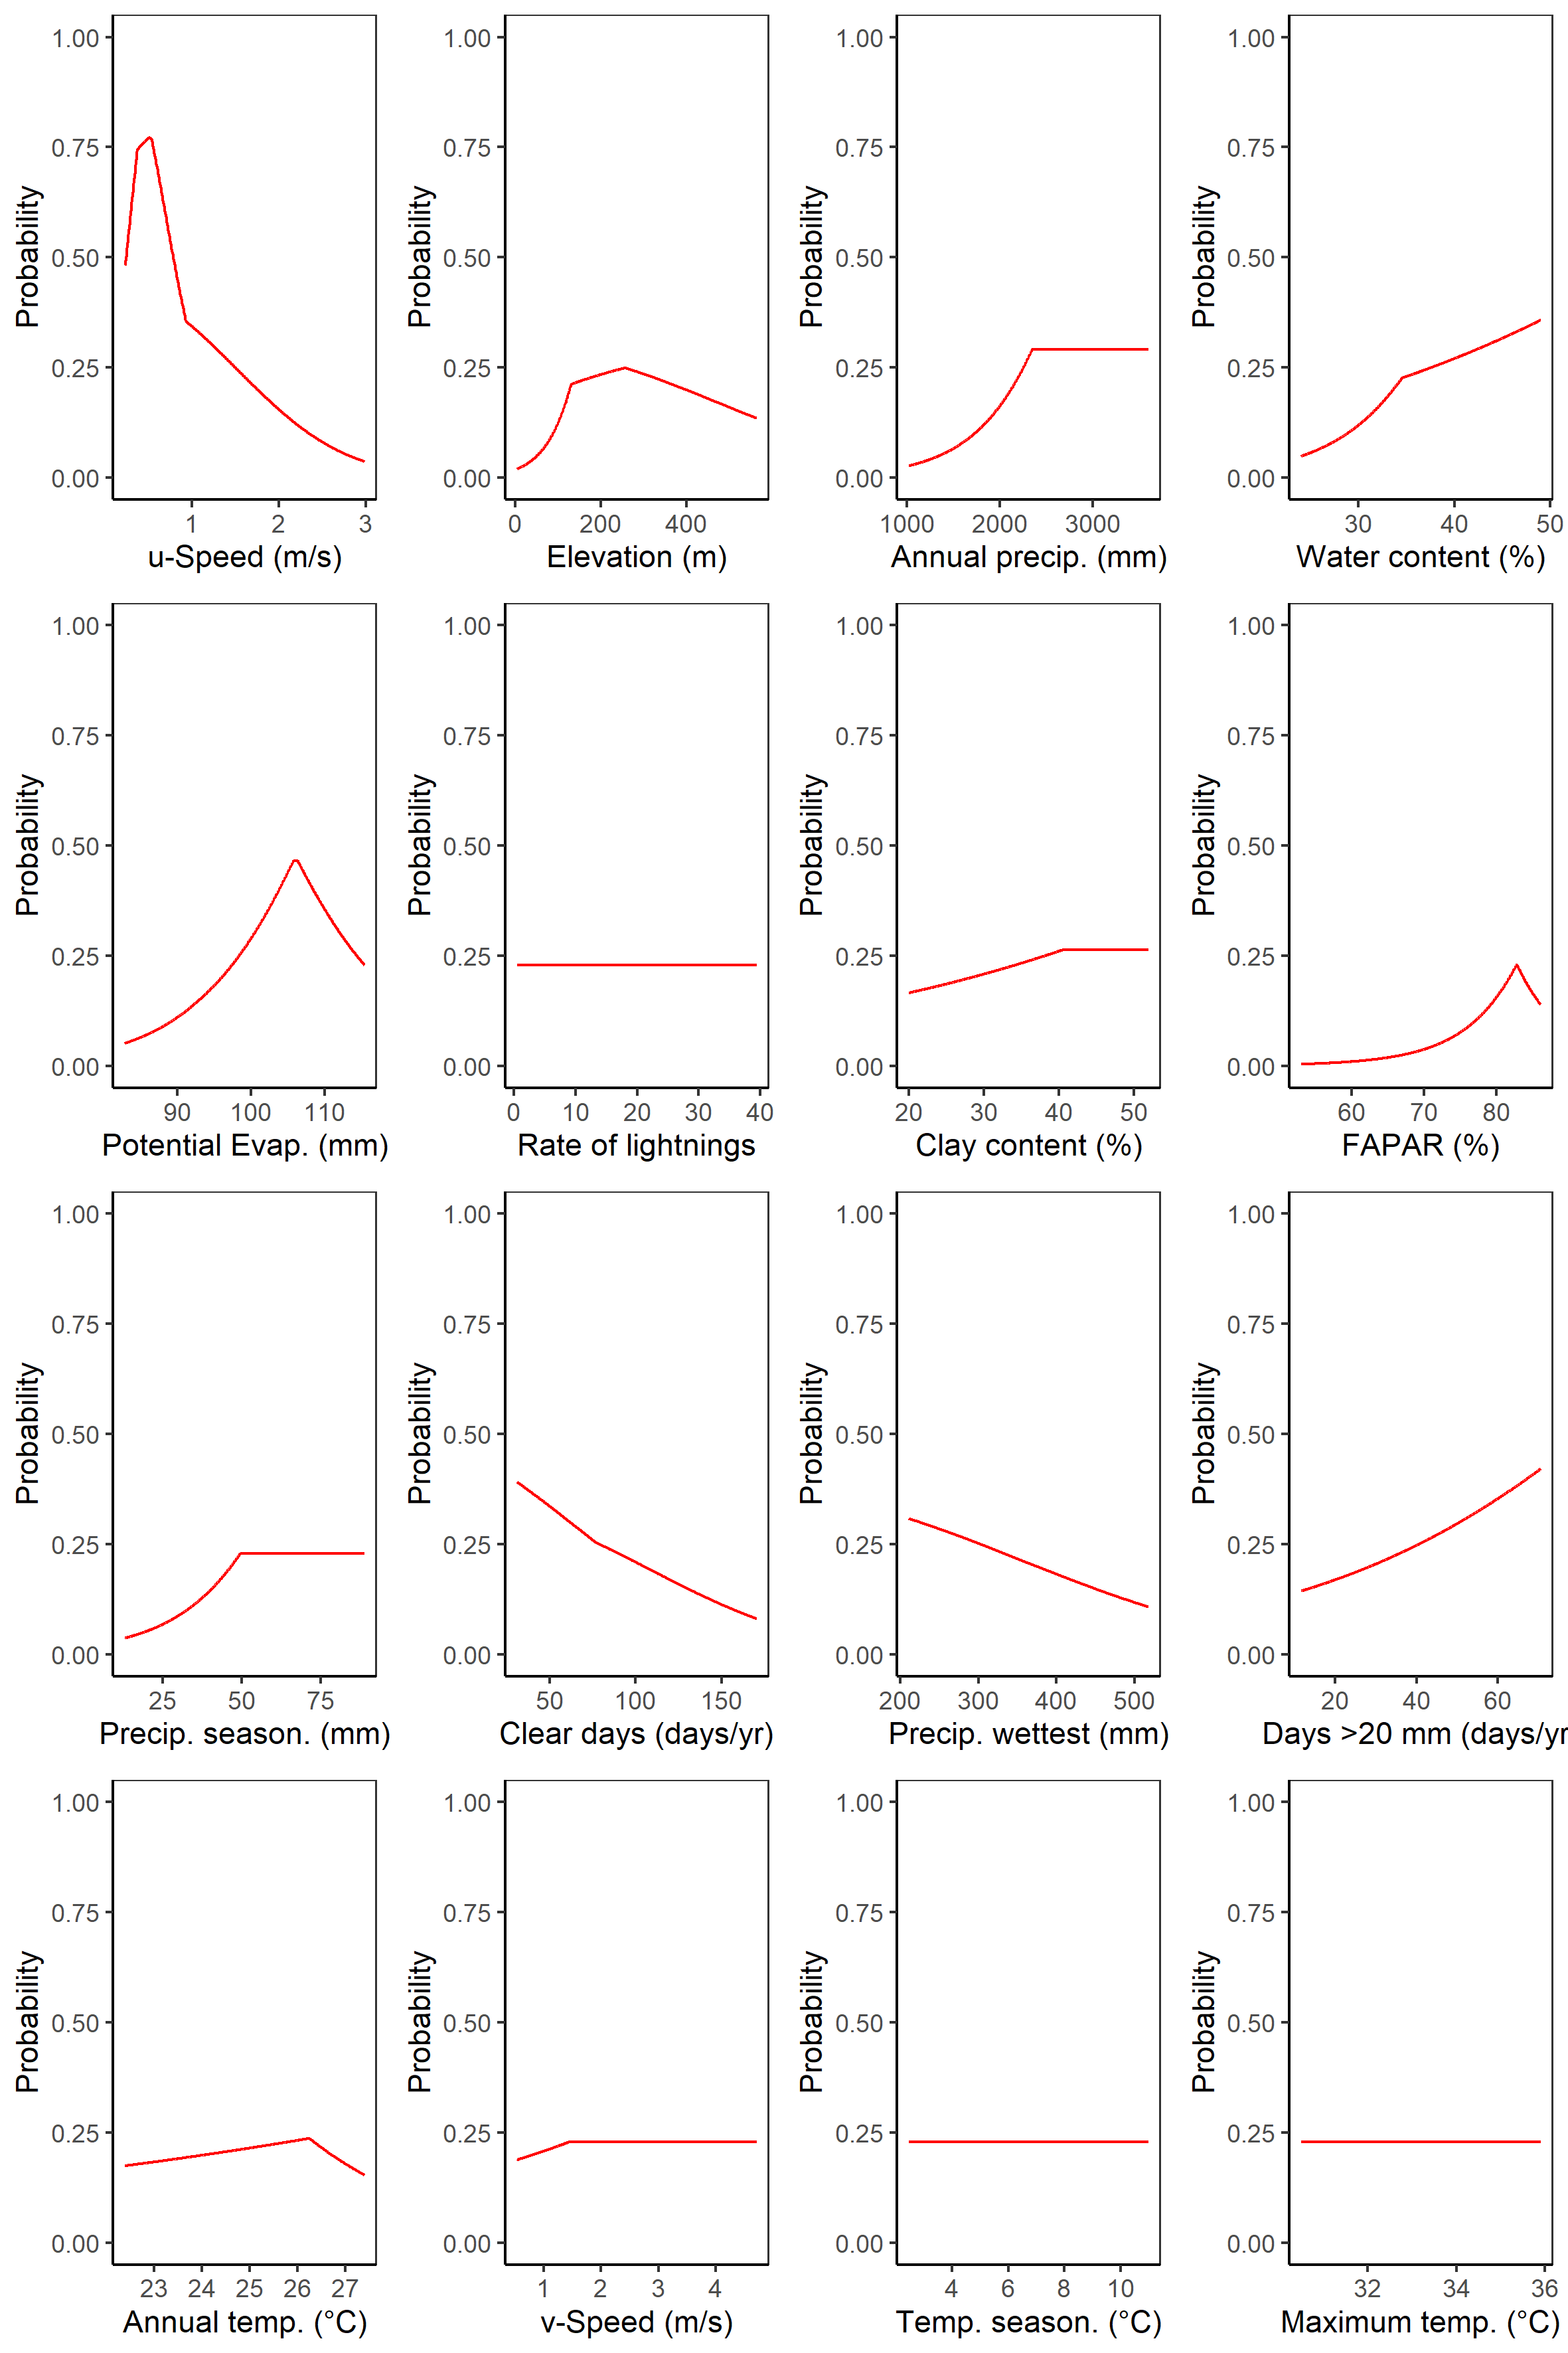

Figure 5. The marginal plot obtained for each environmental variable in the Maximum Entropy model, keeping others constant on the average.

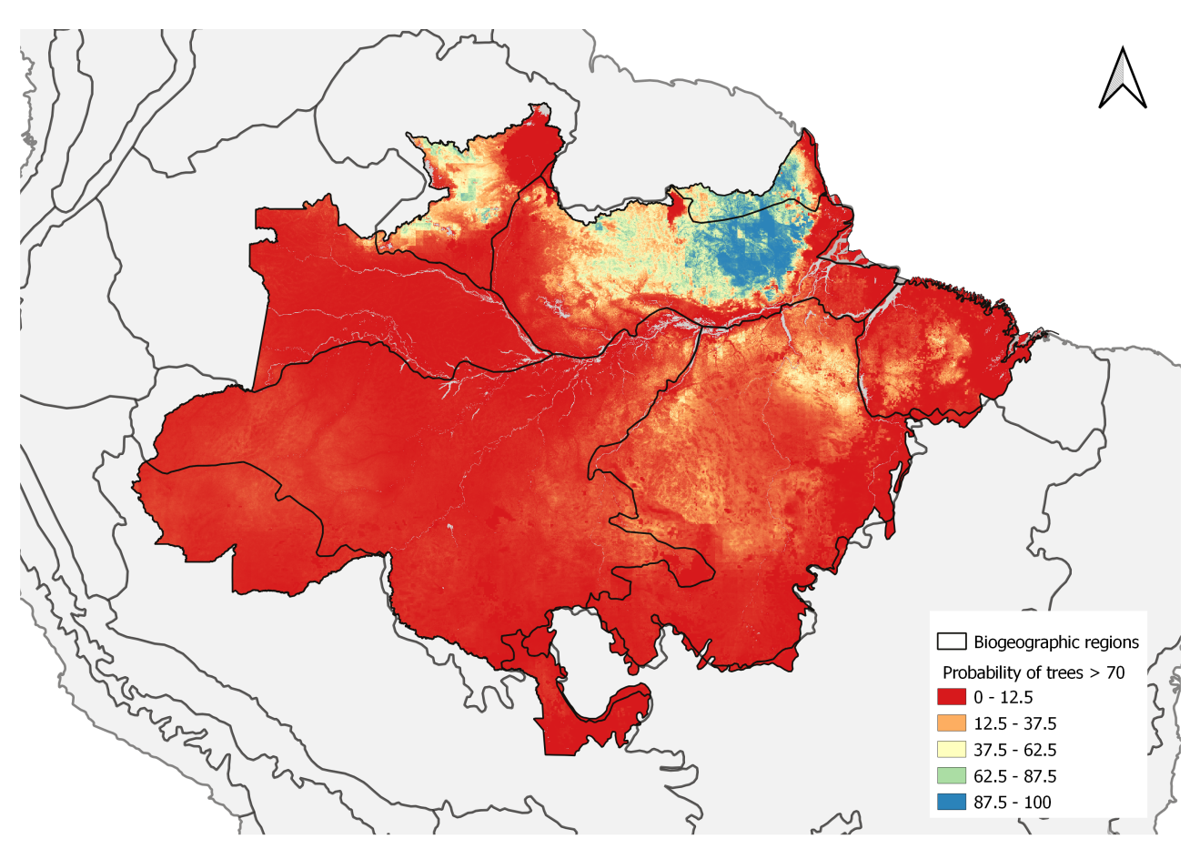

Figure 6. The probability of tall tree occurrence based on environmental conditions estimated by the Maximum Entropy model. The map is available at https://doi.org/10.5281/zenodo.4037101.

# Discussion

We found that maximum tree height across the Brazilian amazon was related to a large number of environmental variables. The number of cloud days stands out as the most relevant variable to explain maximum height distribution, followed closely by wind speed, soil clay content, elevation, precipitation and temperature seasonality, potential evapotranspiration, and maximum temperature. In contrast, the distribution of giant trees >70 m was strongly driven by low wind speeds.

## Maximum height distribution

Many environmental variables with complementary effects on species composition, as well as on their physiological and structural traits, play a crucial role in the tree lifespan (Muller-Landau, 2004) and, consequently, on height development. Previous studies have observed two large-scale gradients in the Amazon affecting forest composition and structure: one from the Guiana Shield to the Southwestern Amazon, related to variation in soil fertility, and another gradient from Colombia to the Southeastern Amazon, related to the length of the dry season (Baker et al. 2004; Malhi et al. 2006; ter Steege et al., 2006).

In our study, maximum height was strongly related to the number of clear days, followed by soil clay content, elevation, annual precipitation and precipitation seasonality. An increase in cloud-free days goes together with an increase in direct solar radiation (Barkhordarian et al., 2019), which, along with changes in the Vapor Pressure Deficit, or atmospheric dryness, leads to water stress in trees (Williams et al., 2012; Nunes et al., 2019). The increase in diffuse radiation led by cloudy conditions induces an increase in photosynthetic activity (Gu, 2003). Tall trees have direct exposure to sunlight and high temperatures and must rely on stomatal control to avoid excessive water loss (Drake et al., 2018; Rowland et al., 2015). Tree responses to direct solar radiation are dependent on the species and developmental stage, with physiological and structural changes to maximize either growth or survival (Wright et al., 2004; Nunes et al., 2019; Poorter & Bongers, 2006). As trees grow taller, increasing leaf water stress due to gravity and path length resistance may limit leaf expansion and photosynthesis, and consequently height growth (Koch et al., 2004).

An increase in soil clay content also translated into an increase in maximum height. In the Amazon, clay content is usually higher on flat terrain (Laurance et al., 1999) decreasing from 75% to 5% when moving from the plateau areas to the valleys (Ferraz et al., 1998; Toledo et al., 2016). A previous study showed an increase in wood density from stands on sandy soils in valleys to clayey soils on plateaus at a local scale in Central Amazon, and lower tree mortality rates in clayey soils (Toledo et al., 2016). We suggest that the well-structured clay soils allow trees to obtain an additional volume of water during the dry season towards eastern Amazon, where soils tend to be richer in clay compared to central and western Amazon (Fisher et al., 2008; Hodnett et al., 1997). The dimorphic root systems associated with structured clayey soils can redistribute water from deep layers to the soil surface during periods of drought (Broedel et al., 2017).

Elevation was also a key predictor of tree height, with low-lying forests growing potentially less than trees in terrains over 40 m a.s.l.. The topographic gradient is likely to be related to the likelihood of flooding in the low elevation transects on the lowlands. Rivers erode the *terra firme* terraces and create floodplains of variable sizes dating to the Miocene, with terrace–floodplain elevation differences decreasing eastwards from the Andes (Hamilton et al., 2007). The terrace and floodplain forests in the Amazon also have differences related to species turnover, which reveals the micro-topography effects on the tree survival rate in Amazonian forests (Asner et al., 2015). Due to higher turnover on floodplains, trees live, on average, for less time and are less likely to achieve giant status

Mean annual precipitation was also a key factor for trees to grow taller. A tolerance curve associated the height of tall trees with precipitation peaked at  2,300 mm  yr-1 and suggested that areas too dry or too wet may both inhibit the growth of tall trees.  We observed a decline in maximum tree height in regions with annual precipitation below 1,500 mm yr-1 or above 3,000 mm yr-1. The availability of soil water depends on both precipitation and evapotranspiration, and our results suggest that below 1,500 mm yr-1 evapotranspiration may exceed precipitation in the Amazon (Scheffer et al., 2018), and mortality by hydraulic failure may be more likely for tall trees under drought conditions (McDowell et al., 2008). Mean annual precipitation above 2,300 mm  year-1 may be related to excess water, and the combination of high precipitation and poorly drained soils may result in anaerobic conditions with negative effects on tree growth and survival (Quesada et al., 2009). Furthermore, higher precipitation tends to be related to the occurrence of storms and stronger winds with increases in tree mortality (Negrón-Juárez et al., 2018, Aleixo et al., 2019).

## Conditions supporting tall trees

In our study, low wind speed was the single most important predictor of the occurrence of the trees over 70 m in the Brazilian Amazon. The fact that trees adapt to their local wind environment and are shorter in windy locations has been widely observed in temperate regions (Telewski, 2006, Bonnesoeur et al., 2016). A balance between tree structural strength and wind shearing forces contributes to set an upper limit to tree height development (Klein et al., 2015). This process of acclimation could drive part of the pattern we observed across the Amazon, with trees over 70 m tall having a 50-75% likelihood of occurring in the calmest areas but a sharply decreasing probability with stronger winds.

The spatial distribution we observed also aligns with disturbance rates, which are three times higher in the Western Amazon than the Eastern (Espírito-Santo et al., 2014). Wind damage is most common from September to February (Negrón-Juárez et al., 2017) and taller trees have higher rates of mortality in wind storms (Rifai et al., 2016). This suggests that wind disturbance, in addition to tree acclimation, shapes the observed patterns of extraordinarily tall trees . The importance of wind speed was also apparent in the Random Forest model which showed a 9 m reduction in the estimated tree height from the calmest to the windiest areas. The zonal velocity (i.e. the eastward component), which is the prevailing wind direction in the region, drives this pattern.

Because the maximum entropy model was highly sensitive to the effect of wind speed, we tested the model excluding both wind speed variables. We found that the importance of variables shifted to lightning (importance changes from 3 to 34), potential evapotranspiration (importance changes from 4 to 18) and precipitation seasonality (importance changes from 0.5 to 15). Secondary factors such elevation, annual precipitation and water content did not change after removing wind speed. These shifts indicate that wind speed is indeed adding information.

Interestingly, our data showed that the lightning rate was only weakly related to maximum forest height patterns in both the Random Forests and MaxEnt models. Despite being relevant to the death of individual trees (Marra et al., 2014; Niklas, 1998) and being the key factor causing large tree deaths in a tropical forest in Panama (Yanoviak et al., 2019), lightning and associated storms were not the dominant factor limit the occurrence of the tallest trees in our analysis.

The locations of the tall trees (> 70 m) in the eastern Amazon coincide with forests that have a high basal area predicted by statistical modelling of permanent plot data (Malhi et al., 2006; ter Steege et al., 2006). Young soils nearer the Andes, as well as the sedimented and flooded lowlands, are richer in nutrients, thereby supporting fast-growing, low wood density species with high turnover rates and, as a result, the trees do not reach extremely large sizes (Marra et al., 2014; Quesada et al., 2011; Phillips et al., 2004). Soil physical properties combined with limited nutrient supply in eastern Amazon favor slow-growing species that invest their resources in structures that can support taller and bigger trees with a long lifespan (Malhi et al., 2004; Quesada et al., 2009).

Understanding the spatial distribution of maximum tree height in tropical forests and how it is associated with environmental conditions and tree functional traits is of fundamental importance. Emergent trees that reach their maximum height are responsible for a significant amount of the transpired water flux and the above-ground carbon storage (Kunert et al. 2017; Bastin et al. 2018). Trees which reach these extraordinary heights are rare and only a small proportion of species have the necessary adaptions to achieve this. However, these adaptations are not sufficient alone, and maximum tree height is strongly influenced by environmental conditions.

Current climate models differ in their predictions of large-scale changes in wind patterns, although warmer temperatures will mean that the air can hold more moisture, which will likely make convective storms more intense. Whatever the change in environmental conditions, it is likely to occur faster than trees can adapt. Our results showed that precipitation and temperature have a lower importance than expected from previous studies. Nevertheless, changes in the precipitation and radiation regimes (strongly linked to the number of cloudy days) could reshape our forest biomes. Ultimately, the association between environmental conditions and mechanisms of natural selection, where some traits have some advantages in comparison to others influencing the survival of the most adaptable, are key to understanding the complexity of this process in a changing climate.

# Acknowledgements

Funding was provided by the Coordenação de Aperfeiçoamento de Pessoal de Nível Superior Brasil (CAPES; Finance Code 001); Conselho Nacional de Desenvolvi­mento Científico e Tecnológico (Processes 403297/2016-8 and 301661/2019-7); Amazon Fund (grant 14.2.0929.1); National Academy of Sciences and US Agency for International Development (grant AID-OAA-A-11-00012); Universidade Federal dos Vales do Jequitinhonha e Mucuri (UFVJM); Instituto Nacional de Pesquisas Espaciais (INPE);

D. Almeida was supported by the São Paulo Research Foundation (#2018/21338-3 and #2019/14697-0);

B. Gimenez, G. Spanner and N. Higuchi were supported by INCT-Madeiras da Amazônia and Next Generation Ecosystem Experiments-Tropics (NGEE-Tropics), as part of DOE’s Terrestrial Ecosystem Science Program – Contract No. DE-AC02-05CH11231;

T. Jackson and D. Coomes were supported by the UK Natural Environment Research Council grant NE/S010750/1;

M. Nunes was supported by the Academy of Finland (decision number 319905);

J. Rosette was supported by the Royal Society University Research Fellowship (URF\R\191014);

# References

Abatzoglou, J. T., Dobrowski, S. Z., Parks, S. A., & Hegewisch, K. C. (2018). TerraClimate a high-resolution global dataset of monthly climate and climatic water balance from 1958-2015. *Scientific Data*, *5*(1). https://doi.org/10.1038/sdata.2017.191

Albergel, C., Dutra, E., Bonan, B., Zheng, Y., Munier, S., Balsamo, G., de Rosnay, P., Muñoz-Sabater, J., & Calvet, J.-C. (2019). Monitoring and Forecasting the Impact of the 2018 Summer Heatwave on Vegetation. *Remote Sensing*, *11*(5), 520. https://doi.org/10.3390/rs11050520

Albrecht, R. I., Goodman, S. J., Buechler, D. E., Blakeslee, R. J., & Christian, H. J. (2016). Where Are the Lightning Hotspots on Earth? *Bulletin of the American Meteorological Society*, *97*(11), 2051–2068. https://doi.org/10.1175/bams-d-14-00193.1

Aleixo, I., Norris, D., Hemerik, L., Barbosa, A., Prata, E., Costa, F., & Poorter, L. (2019). Amazonian rainforest tree mortality driven by climate and functional traits. *Nature Climate Change*, *9*(5), 384–388. https://doi.org/10.1038/s41558-019-0458-0

Almeida, D. R. A., Stark, S. C., Schietti, J., Camargo, J. L. C., Amazonas, N. T., Gorgens, E. B., Rosa, D. M., Smith, M. N., Valbuena, R., Saleska, S., Andrade, A., Mesquita, R., Laurance, S. G., Laurance, W. F., Lovejoy, T. E., Broadbent, E. N., Shimabukuro, Y. E., Parker, G. G., Lefsky, M., … Brancalion, P. H. S. (2019). Persistent effects of fragmentation on tropical rainforest canopy structure after 20~yr of isolation. *Ecological Applications*, *29*(6). https://doi.org/10.1002/eap.1952

Anderegg, W. R. L., Klein, T., Bartlett, M., Sack, L., Pellegrini, A. F. A., Choat, B., & Jansen, S. (2016). Meta-analysis reveals that hydraulic traits explain cross-species patterns of drought-induced tree mortality across the globe. *Proceedings of the National Academy of Sciences*, *113*(18), 5024–5029. https://doi.org/10.1073/pnas.1525678113

Andrade, M. S., Gorgens, E. B., Reis, C. R., Cantinho, R. Z., Assis, M., Sato, L., & Ometto, J. P. H. B. (2018). Airborne laser scanning for terrain modeling in the amazon forest. *Acta Amazonica*, *48*(4), 271–279. https://doi.org/10.1590/1809-4392201800132

Arsanjani, J. J., Vaz, E., Bakillah, M., & Mooney, P. (2014). Towards initiating OpenLandMap founded on citizens’ science: The current status of land use features of OpenStreetMap in Europe. *International Conference on Geographic Information Science*.

Asner, G. P., Powell, G. V. N., Mascaro, J., Knapp, D. E., Clark, J. K., Jacobson, J., Kennedy-Bowdoin, T., Balaji, A., Paez-Acosta, G., Victoria, E., Secada, L., Valqui, M., & Hughes, R. F. (2010). High-resolution forest carbon stocks and emissions in the Amazon. *Proceedings of the National Academy of Sciences*, *107*(38), 16738–16742. https://doi.org/10.1073/pnas.1004875107

Asner, G. P. (2009). Tropical forest carbon assessment: integrating satellite and airborne mapping approaches. *Environmental Research Letters*, *4*(3), 34009. https://doi.org/10.1088/1748-9326/4/3/034009

Asner, G. P., Anderson, C. B., Martin, R. E., Tupayachi, R., Knapp, D. E., & Sinca, F. (2015). Landscape biogeochemistry reflected in shifting distributions of chemical traits in the Amazon forest canopy. *Nature Geoscience*, *8*(7), 567–573.

Bae, S., Levick, S. R., Heidrich, L., Magdon, P., Leutner, B. F., Wöllauer, S., Serebryanyk, A., Nauss, T., Krzystek, P., Gossner, M. M., Schall, P., Heibl, C., Bässler, C., Doerfler, I., Schulze, E.-D., Krah, F.-S., Culmsee, H., Jung, K., Heurich, M., … Müller, J. (2019). Radar vision in the mapping of forest biodiversity from space. *Nature Communications*, *10*(1). https://doi.org/10.1038/s41467-019-12737-x

Barkhordarian, A., Saatchi, S. S., Behrangi, A., Loikith, P. C., & Mechoso, C. R. (2019). A Recent Systematic Increase in Vapor Pressure Deficit over Tropical South America. *Scientific Reports*, *9*(1). https://doi.org/10.1038/s41598-019-51857-8

Bennett, A. C., McDowell, N. G., Allen, C. D., & Anderson-Teixeira, K. J. (2015). Larger trees suffer most during drought in forests worldwide. *Nature Plants*, *1*(10). https://doi.org/10.1038/nplants.2015.139

Binkley, D., Stape, J. L., & Ryan, M. G. (2004). Thinking about efficiency of resource use in forests. *Forest Ecology and Management*, *193*(1–2), 5–16. https://doi.org/10.1016/j.foreco.2004.01.019

Bisht, G., & Bras, R. L. (2010). Estimation of net radiation from the {MODIS} data under all sky conditions: Southern Great Plains case study. *Remote Sensing of Environment*, *114*(7), 1522–1534. https://doi.org/10.1016/j.rse.2010.02.007

Bonnesoeur, V., Constant, T., Moulia, B., & Fournier, M. (2016). Forest trees filter chronic wind-signals to acclimate to high winds. *New Phytologist*, *210*(3), 850–860. https://doi.org/10.1111/nph.13836

Broedel, E., Tomasella, J., Cândido, L. A., & von Randow, C. (2017). Deep soil water dynamics in an undisturbed primary forest in central Amazonia: Differences between normal years and the 2005 drought. *Hydrological Processes*, *31*(9), 1749–1759. https://doi.org/10.1002/hyp.11143

Cao, M., & Woodward, F. I. (1998). Net primary and ecosystem production and carbon stocks of terrestrial ecosystems and their responses to climate change. *Global Change Biology*, *4*(2), 185–198. https://doi.org/10.1046/j.1365-2486.1998.00125.x

Chave, J., Piponiot, C., Maréchaux, I., de, F. H., Larpin, D., Fischer, F. J., Derroire, G., Vincent, G., & Hérault, B. (2020). Slow rate of secondary forest carbon accumulation in the Guianas compared with the rest of the Neotropics. *Ecol Appl*, *30*, e02004.

Clark, M. L., Clark, D. B., & Roberts, D. A. (2004). Small-footprint lidar estimation of sub-canopy elevation and tree height in a tropical rain forest landscape. *Remote Sensing of Environment*, *91*(1), 68–89. https://doi.org/10.1016/j.rse.2004.02.008

Coomes, D. A., Dalponte, M., Jucker, T., Asner, G. P., Banin, L. F., Burslem, D. F. R. P., Lewis, S. L., Nilus, R., Phillips, O. L., Phua, M.-H., & Qie, L. (2017). Area-based vs tree-centric approaches to mapping forest carbon in Southeast Asian forests from airborne laser scanning data. *Remote Sensing of Environment*, *194*, 77–88. https://doi.org/10.1016/j.rse.2017.03.017

Coomes, D. A., Jenkins, K. L., & Cole, L. E. S. (2006). Scaling of tree vascular transport systems along gradients of nutrient supply and altitude. *Biology Letters*, *3*(1), 87–90. https://doi.org/10.1098/rsbl.2006.0551

Cosme, L. H. M., Schietti, J., Costa, F. R. C., & Oliveira, R. S. (2017). The importance of hydraulic architecture to the distribution patterns of trees in a central Amazonian forest. *New Phytologist*, *215*(1), 113–125. https://doi.org/10.1111/nph.14508

Daubenmire, R. (1976). The use of vegetation in assessing the productivity of forest lands. *The Botanical Review*, *42*(2), 115–143. https://doi.org/10.1007/BF02860720

Drake, J. E., Tjoelker, M. G., Vårhammar, A., Medlyn, B., Reich, P. B., Leigh, A., Pfautsch, S., Blackman, C. J., López, R., Aspinwall, M. J., Crous, K. Y., Duursma, R. A., Kumarathunge, D., Kauwe, M. G. De, Jiang, M., Nicotra, A. B., Tissue, D. T., Choat, B., Atkin, O. K., & Barton, C. V. M. (2018). Trees tolerate an extreme heatwave via sustained transpirational cooling and increased leaf thermal tolerance. *Global Change Biology*, *24*(6), 2390–2402. https://doi.org/10.1111/gcb.14037

Enquist, B. J., Abraham, A. J., Harfoot, M. B. J., Malhi, Y., & Doughty, C. E. (2020). The megabiota are disproportionately important for biosphere functioning. *Nature Communications*, *11*(1). https://doi.org/10.1038/s41467-020-14369-y

Espírito-Santo, F. D. B., Gloor, M., Keller, M., Malhi, Y., Saatchi, S., Nelson, B., Junior, R. C. O., Pereira, C., Lloyd, J., Frolking, S., Palace, M., Shimabukuro, Y. E., Duarte, V., Mendoza, A. M., López-González, G., Baker, T. R., Feldpausch, T. R., Brienen, R. J. W., Asner, G. P., … Phillips, O. L. (2014). Size and frequency of natural forest disturbances and the Amazon forest carbon balance. *Nature Communications*, *5*, 1–6. https://doi.org/10.1038/ncomms4434

Farr, T. G., Rosen, P. A., Caro, E., Crippen, R., Duren, R., Hensley, S., Kobrick, M., Paller, M., Rodriguez, E., Roth, L., & others. (2007). The shuttle radar topography mission. *Reviews of Geophysics*, *45*(2).

Feldpausch, T. R., Lloyd, J., Lewis, S. L., Brienen, R. J. W. W., Gloor, M., Monteagudo Mendoza, A., Lopez-Gonzalez, G., Banin, L., Abu Salim, K., Affum-Baffoe, K., others, Alexiades, M., Almeida, S., Amaral, I., Andrade, A., Aragão, L. E. O. C., Araujo Murakami, A., Arets, E. J. M., Arroyo, L., … Phillips, O. L. (2012). Tree height integrated into pantropical forest biomass estimates. *Biogeosciences*, *9*(8), 3381–3403. https://doi.org/10.5194/bg-9-3381-2012

Ferraz, J., Ohta, S., & Sales, P. C. de. (1998). Distribuição dos solos ao longo de dois transectos em floresta primária ao norte de Manaus (AM). *Higuchi, N., Campos, MAA, Sampaio, PTB, and Dos Santos, J., Espaço Comunicaçao Ltda., Manaus, Brazil*, *264*.

Fick, S. E., & Hijmans, R. J. (2017). WorldClim2: new 1-km spatial resolution climate surfaces for global land areas. *International Journal of Climatology*, *37*(12), 4302–4315. https://doi.org/10.1002/joc.5086

Fisher, R. A., Williams, M., de Lourdes Ruivo, M., de Costa, A. L., & Meir, P. (2008). Evaluating climatic and soil water controls on evapotranspiration at two Amazonian rainforest sites. *Agricultural and Forest Meteorology*, *148*(6–7), 850–861. https://doi.org/10.1016/j.agrformet.2007.12.001

Funk, C., Peterson, P., Landsfeld, M., Pedreros, D., Verdin, J., Shukla, S., Husak, G., Rowland, J., Harrison, L., Hoell, A., & Michaelsen, J. (2015). The climate hazards infrared precipitation with stations{\textemdash}a new environmental record for monitoring extremes. *Scientific Data*, *2*(1). https://doi.org/10.1038/sdata.2015.66

Glenn, N. F., Spaete, L. P., Sankey, T. T., Derryberry, D. R., Hardegree, S. P., & Mitchell, J. (2011). Errors in LiDAR-derived shrub height and crown area on sloped terrain. *Journal of Arid Environments*, *75*(4), 377–382. https://doi.org/10.1016/j.jaridenv.2010.11.005

Görgens, E. B., Soares, C. P. B., Nunes, M. H., & Rodriguez, L. C. E. (2016). Characterization of Brazilian forest types utilizing canopy height profiles derived from airborne laser scanning. *Applied Vegetation Science*, *19*(3), 518–527. https://doi.org/10.1111/avsc.12224

Gorgens, E. B., Motta, A. Z., Assis, M., Nunes, M. H., Jackson, T., Coomes, D., Rosette, J., e Cruz Aragão, L. E. O., Ometto, J. P., Aragão, L. E. O. e. C., & Ometto, J. P. (2019). The giant trees of the Amazon basin. *Frontiers in Ecology and the Environment*, *17*(7), 373–374. https://doi.org/10.1002/fee.2085

Gu, L. (2003). Response of a Deciduous Forest to the Mount Pinatubo Eruption: Enhanced Photosynthesis. *Science*, *299*(5615), 2035–2038. https://doi.org/10.1126/science.1078366

Hamilton, S. K., Kellndorfer, J., Lehner, B., & Tobler, M. (2007). Remote sensing of floodplain geomorphology as a surrogate for biodiversity in a tropical river system (Madre de Dios Peru). *Geomorphology*, *89*(1–2), 23–38. https://doi.org/10.1016/j.geomorph.2006.07.024

Hijmans, R. J., Cameron, S. E., Parra, J. L., Jones, P. G., & Jarvis, A. (2005). Very high resolution interpolated climate surfaces for global land areas. *International Journal of Climatology*, *25*(15), 1965–1978. https://doi.org/10.1002/joc.1276

Hodnett, M. G., Vendrame, I., Marques Filho, A. D. O., Oyama, M. D., & Tomasella, J. (1997). Soil water storage and groundwater behaviour in a catenary sequence beneath forest in central Amazonia: I. Comparisons between plateau, slope and valley floor. *Hydrology and Earth System Sciences Discussions*, *1*.

Jagels, R., Equiza, M. A., Maguire, D. A., & Cirelli, D. (2018). Do tall tree species have higher relative stiffness than shorter species? *American Journal of Botany*, *105*(10), 1617–1630. https://doi.org/10.1002/ajb2.1171

Kang, S., Running, S. W., Zhao, M., Kimball, J. S., & Glassy, J. (2005). Improving continuity of {MODIS} terrestrial photosynthesis products using an interpolation scheme for cloudy pixels. *International Journal of Remote Sensing*, *26*(8), 1659–1676. https://doi.org/10.1080/01431160512331326693

Klein, T., Randin, C., & Körner, C. (2015). Water availability predicts forest canopy height at the global~scale. *Ecology Letters*, *18*(12), 1311–1320. https://doi.org/10.1111/ele.12525

Koch, G. W., Sillett, S. C., Jennings, G. M., & Davis, S. D. (2004). The limits to tree height. *Nature*, *428*(6985), 851–854. https://doi.org/10.1038/nature02417

Larjavaara, M. (2013). The world{\textquotesingle}s tallest trees grow in thermally similar climates. *New Phytologist*, *202*(2), 344–349. https://doi.org/10.1111/nph.12656

Laurance, W. F., Fearnside, P. M., Laurance, S. G., Delamonica, P., Lovejoy, T. E., Merona, J. M. R., Chambers, J. Q., & Gascon, C. (1999). Relationship between soils and Amazon forest biomass: a landscape-scale study. *Forest Ecology and Management*, *118*(1–3), 127–138. https://doi.org/10.1016/s0378-1127(98)00494-0

Lefsky, M. A. (2010). A global forest canopy height map from the moderate resolution imaging spectroradiometer and the geoscience laser altimeter system. *Geophysical Research Letters*, *37*(15), 1–5. https://doi.org/10.1029/2010GL043622

Lindenmayer, D. B., & Laurance, W. F. (2016). The Unique Challenges of Conserving Large Old Trees. *Trends in Ecology & Evolution*, *31*(6), 416–418. https://doi.org/10.1016/j.tree.2016.03.003

Liu, J., Liu, D., & Alsdorf, D. (2014). Extracting Ground-Level DEM From SRTM DEM in Forest Environments Based on Mathematical Morphology. *IEEE Transactions on Geoscience and Remote Sensing*, *52*(10), 6333–6340. https://doi.org/10.1109/tgrs.2013.2296232

Malhi, Y., Baker, T. R., Phillips, O. L., Almeida, S., Alvarez, E., Arroyo, L., Chave, J., Czimczik, C. I., Fiore, A. Di, Higuchi, N., Killeen, T. J., Laurance, S. G., Laurance, W. F., Lewis, S. L., Montoya, L. M. M., Monteagudo, A., Neill, D. A., Vargas, P. N., Patino, S., … Lloyd, J. (2004). The above-ground coarse wood productivity of 104 Neotropical forest plots. *Global Change Biology*, *10*(5), 563–591. https://doi.org/10.1111/j.1529-8817.2003.00778.x

Malhi, Y., Wood, D., Baker, T. R., Wright, J., Phillips, O. L., Cochrane, T., Meir, P., Chave, J., Almeida, S., Arroyo, L., & others. (2006). The regional variation of aboveground live biomass in old-growth Amazonian forests. *Global Change Biology*, *12*(7), 1107–1138. https://doi.org/10.1111/j.1365-2486.2006.01120.x

Marra, D. M., Chambers, J. Q., Higuchi, N., Trumbore, S. E., Ribeiro, G. H. P. M., dos Santos, J., Negrón-Juárez, R. I., Reu, B., & Wirth, C. (2014). Large-Scale Wind Disturbances Promote Tree Diversity in a Central Amazon Forest. *PLoS ONE*, *9*(8), e103711. https://doi.org/10.1371/journal.pone.0103711

Marvin, D. C., Asner, G. P., Knapp, D. E., Anderson, C. B., Martin, R. E., Sinca, F., & Tupayachi, R. (2014). Amazonian landscapes and the bias in field studies of forest structure and biomass. *Proceedings of the National Academy of Sciences*, *111*(48), E5224--E5232. https://doi.org/10.1073/pnas.1412999111

Mason, P. J., Zillman, J. W., Simmons, A., Lindstrom, E. J., Harrison, D. E., Dolman, H., Bojinski, S., Fischer, A., Latham, J., Rasmussen, J., & others. (2010). Implementation plan for the global observing system for climate in support of the UNFCCC (2010 Update). In UNFCCC (Ed.), *Conference of the Parties (COP)*. WMO, IOC, UNEP, ICSU.

McDowell, N., Pockman, W. T., Allen, C. D., Breshears, D. D., Cobb, N., Kolb, T., Plaut, J., Sperry, J., West, A., Williams, D. G., & Yepez, E. A. (2008). Mechanisms of plant survival and mortality during drought: why do some plants survive while others succumb to drought? *New Phytologist*, *178*(4), 719–739. https://doi.org/10.1111/j.1469-8137.2008.02436.x

McDowell, N. G., & Allen, C. D. (2015). Darcy’s law predicts widespread forest mortality under climate warming. *Nature Climate Change*, *5*(7), 669–672. https://doi.org/10.1038/nclimate2641

Moles, A. T., Warton, D. I., Warman, L., Swenson, N. G., Laffan, S. W., Zanne, A. E., Pitman, A., Hemmings, F. A., & Leishman, M. R. (2009). Global patterns in plant height. *Journal of Ecology*, *97*(5), 923–932.

Morrone, J. J. (2014). Biogeographical regionalisation of the Neotropical region. *Zootaxa*, *3782*(1), 1. https://doi.org/10.11646/zootaxa.3782.1.1

Muller-Landau, H. C. (2004). Interspecific and Inter-site Variation in Wood Specific Gravity of Tropical Trees. *Biotropica*, *36*(1), 20–32. https://doi.org/10.1111/j.1744-7429.2004.tb00292.x

Negrón-Juárez, R. I., Jenkins, H. S., Raupp, C. F. M., Riley, W. J., Kueppers, L. M., Magnabosco Marra, D., Ribeiro, G. H. P. M., Monteiro, M. T. F., Candido, L. A., Chambers, J. Q., & Higuchi, N. (2017). Windthrow Variability in Central Amazonia. *Atmosphere*, *8*(2). https://doi.org/10.3390/atmos8020028

Negrón-Juárez, R. I., Holm, J. A., Marra, D. M., Rifai, S. W., Riley, W. J., Chambers, J. Q., Koven, C. D., Knox, R. G., McGroddy, M. E., Di Vittorio, A. V., Urquiza-Muñoz, J., Tello-Espinoza, R., Muñoz, W. A., Ribeiro, G. H. P. M., & Higuchi, N. (2018). Vulnerability of Amazon forests to storm-driven tree mortality. *Environmental Research Letters*, *13*(5). https://doi.org/10.1088/1748-9326/aabe9f

Niklas, K. J. (1998). The influence of gravity and wind on land plant evolution. *Review of Palaeobotany and Palynology*, *102*(1–2), 1–14. https://doi.org/10.1016/s0034-6667(98)00011-6

Niklas, K. J. (2007). Maximum plant height and the biophysical factors that limit it. *Tree Physiology*, *27*(3), 433–440. https://doi.org/10.1093/treephys/27.3.433

Nunes, M. H., Both, S., Bongalov, B., Brelsford, C., Khoury, S., Burslem, D. F. R. P., Philipson, C., Majalap, N., Riutta, T., Coomes, D. A., & Cutler, M. E. J. (2019). Changes in leaf functional traits of rainforest canopy trees associated with an El Niño event in Borneo. *Environmental Research Letters*, *14*(8), 85005. https://doi.org/10.1088/1748-9326/ab2eae

Olauson, J. (2018). {ERA}5: The new champion of wind power modelling? *Renewable Energy*, *126*, 322–331. https://doi.org/10.1016/j.renene.2018.03.056

Phillips, O. L., Baker, T. R., Arroyo, L., Higuchi, N., Killeen, T. J., Laurance, W. F., Lewis, S. L., Lloyd, J., Malhi, Y., Monteagudo, A., & others. (2004). Pattern and process in Amazon tree turnover, 1976--2001. *Philosophical Transactions of the Royal Society of London. Series B: Biological Sciences*, *359*(1443), 381–407.

Phillips, S. J., Anderson, R. P., & Schapire, R. E. (2006). Maximum entropy modeling of species geographic distributions. *Ecological Modelling*, *190*(3–4), 231–259. https://doi.org/10.1016/j.ecolmodel.2005.03.026

Poorter, L., & Bongers, F. (2006). Leaf traits are good predictors of plant performance across 53 rain forest species. *Ecology*, *87*(7), 1733–1743.

Powers, J. S., Vargas-G, G., Brodribb, T. J., Schwartz, N. B., Perez-Aviles, D., Smith-Martin, C. M., Becknell, J. M., Aureli, F., Blanco, R., Calderón-Morales, E., Calvo-Alvarado, J. C., Calvo-Obando, A. J., Chavarr\’\ia, M. M., Carvajal-Vanegas, D., Jiménez-Rodr\’\iguez, C. D., Chacon, E. M., Schaffner, C. M., Werden, L. K., Xu, X., & Medvigy, D. (2020). A catastrophic tropical drought kills hydraulically vulnerable tree species. *Global Change Biology*. https://doi.org/10.1111/gcb.15037

Quesada, C. A., Lloyd, J., Anderson, L. O., Fyllas, N. M., Schwarz, M., & Czimczik, C. I. (2011). Soils of Amazonia with particular reference to the {RAINFOR} sites. *Biogeosciences*, *8*(6), 1415–1440. https://doi.org/10.5194/bg-8-1415-2011

Quesada, C. A., Lloyd, J., Schwarz, M., Baker, T. R., Phillips, O. L., Patiño, S., Czimczik, C., Hodnett, M. G., Herrera, R., Arneth, A., & others. (2009). Regional and large-scale patterns in Amazon forest structure and function are mediated by variations in soil physical and chemical properties. *Biogeosciences Discussion*, *6*, 3993–4057.

Ramon, J., Lledó, L., Torralba, V., Soret, A., & Doblas-Reyes, F. J. (2019). What global reanalysis best represents near-surface winds? *Quarterly Journal of the Royal Meteorological Society*, *145*(724), 3236–3251. https://doi.org/10.1002/qj.3616

Rifai, S. W., Urquiza Muñoz, J. D., Negrón-Juárez, R. I., Ram\’\irez Arévalo, F. R., Tello-Espinoza, R., Vanderwel, M. C., Lichstein, J. W., Chambers, J. Q., & Bohlman, S. A. (2016). Landscape-scale consequences of differential tree mortality from catastrophic wind disturbance in the Amazon. *Ecological Applications*, *26*(7), 2225–2237.

Rowland, L., da Costa, A. C. L., Galbraith, D. R., Oliveira, R. S., Binks, O. J., Oliveira, A. A. R., Pullen, A. M., Doughty, C. E., Metcalfe, D. B., Vasconcelos, S. S., Ferreira, L. V, Malhi, Y., Grace, J., Mencuccini, M., & Meir, P. (2015). Death from drought in tropical forests is triggered by hydraulics not carbon starvation. *Nature*, *528*(7580), 119–122. https://doi.org/10.1038/nature15539

Rueda, M., Godoy, O., & Hawkins, B. A. (2016). Spatial and evolutionary parallelism between shade and drought tolerance explains the distributions of conifers in the conterminous United States. *Global Ecology and Biogeography*, *26*(1), 31–42. https://doi.org/10.1111/geb.12511

Sakschewski, B., von Bloh, W., Boit, A., Poorter, L., Peña-Claros, M., Heinke, J., Joshi, J., & Thonicke, K. (2016). Resilience of Amazon forests emerges from plant trait~diversity. *Nature Climate Change*, *6*(11), 1032–1036. https://doi.org/10.1038/nclimate3109

Scheffer, M., Xu, C., Hantson, S., Holmgren, M., Los, S. O., van, N. E. H., & van Nes, E. H. (2018). A global climate niche for giant trees. *Global Change Biology*, *24*(7), 2875–2883. https://doi.org/10.1111/gcb.14167

Schimel, D., Pavlick, R., Fisher, J. B., Asner, G. P., Saatchi, S., Townsend, P., Miller, C., Frankenberg, C., Hibbard, K., & Cox, P. (2015). Observing terrestrial ecosystems and the carbon cycle from space. *Global Change Biology*, *21*(5), 1762–1776. https://doi.org/10.1111/gcb.12822

Simard, M., Pinto, N., Fisher, J. B., & Baccini, A. (2011). Mapping forest canopy height globally with spaceborne lidar. *Journal of Geophysical Research: Biogeosciences*, *116*(4), 1–12. https://doi.org/10.1029/2011JG001708

Stropp, J., Umbelino, B., Correia, R. A., Campos-Silva, J. V, Ladle, R. J., & Malhado, A. C. M. (2020). The ghosts of forests past and future: deforestation and botanical sampling in the Brazilian Amazon. *Ecography*. https://doi.org/10.1111/ecog.05026

Tao, S., Guo, Q., Li, C., Wang, Z., & Fang, J. (2016). Global patterns and determinants of forest canopy height. *Ecology*, *97*(12), 3265–3270. https://doi.org/10.1002/ecy.1580

Tao, X., Liang, S., He, T., & Jin, H. (2016). Estimation of fraction of absorbed photosynthetically active radiation from multiple satellite data: Model development and validation. *Remote Sensing of Environment*, *184*, 539–557. https://doi.org/10.1016/j.rse.2016.07.036

Tejada, G., Görgens, E. B., Esp\’\irito-Santo, F. D. B., Cantinho, R. Z., & Ometto, J. P. (2019). Evaluating spatial coverage of data on the aboveground biomass in undisturbed forests in the Brazilian Amazon. *Carbon Balance and Management*, *14*(1). https://doi.org/10.1186/s13021-019-0126-8

Telewski, F. W. (2006). A unified hypothesis of mechanoperception in plants. *American Journal of Botany*, *93*(10), 1466–1476. https://doi.org/10.3732/ajb.93.10.1466

ter Steege, H., Pitman, N. C. A., Phillips, O. L., Chave, J., Sabatier, D., Duque, A., Molino, J.-F., Prévost, M.-F., Spichiger, R., Castellanos, H., von Hildebrand, P., & Vásquez, R. (2006). Continental-scale patterns of canopy tree composition and function across Amazonia. *Nature*, *443*(7110), 444–447. https://doi.org/10.1038/nature05134

Toledo, J. J., Castilho, C. V, Magnusson, W. E., & Nascimento, H. E. M. (2016). Soil controls biomass and dynamics of an Amazonian forest through the shifting of species and traits. *Brazilian Journal of Botany*, *40*(2), 451–461. https://doi.org/10.1007/s40415-016-0351-2

Tuomisto, H., Van doninck, J., Ruokolainen, K., Moulatlet, G. M., Figueiredo, F. O. G. G., Sirén, A., Cárdenas, G., Lehtonen, S., Zuquim, G., doninck, J. Van, Ruokolainen, K., Moulatlet, G. M., Figueiredo, F. O. G. G., Sirén, A., Cárdenas, G., Lehtonen, S., & Zuquim, G. (2019). Discovering floristic and geoecological gradients across Amazonia. *Journal of Biogeography*, *46*(8), 1734–1748. https://doi.org/10.1111/jbi.13627

van Gelder, H. A., Poorter, L., & Sterck, F. J. (2006). Wood mechanics allometry, and life-history variation in a tropical rain forest tree community. *New Phytologist*, *171*(2), 367–378. https://doi.org/10.1111/j.1469-8137.2006.01757.x

Vanclay, J. K. (1992). Assessing site productivity in tropical moist forests: a review. *Forest Ecology and Management*, *54*(1–4), 257–287. https://doi.org/10.1016/0378-1127(92)90017-4

Webb, J. R., & Sprent, J. I. (2002). Nodulation in Legumes. *Kew Bulletin*, *57*(3), 634. https://doi.org/10.2307/4110991

Williams, A. P., Allen, C. D., Macalady, A. K., Griffin, D., Woodhouse, C. A., Meko, D. M., Swetnam, T. W., Rauscher, S. A., Seager, R., Grissino-Mayer, H. D., Dean, J. S., Cook, E. R., Gangodagamage, C., Cai, M., & McDowell, N. G. (2012). Temperature as a potent driver of regional forest drought stress and tree mortality. *Nature Climate Change*, *3*(3), 292–297. https://doi.org/10.1038/nclimate1693

Wright, I. J., Reich, P. B., Westoby, M., Ackerly, D. D., Baruch, Z., Bongers, F., Cavender-Bares, J., Chapin, T., Cornelissen, J. H., Diemer, M., Flexas, J., Garnier, E., Groom, P. K., Gulias, J., Hikosaka, K., Lamont, B. B., Lee, T., Lee, W., Lusk, C., … Villar, R. (2004). The worldwide leaf economics spectrum. *Nature*, *428*, 821–827.

Yang, Y., Saatchi, S., Xu, L., Yu, Y., Lefsky, M., White, L., Knyazikhin, Y., & Myneni, R. (2016). Abiotic Controls on Macroscale Variations of Humid Tropical Forest Height. *Remote Sensing*, *8*(6), 494. https://doi.org/10.3390/rs8060494

Yanoviak, S. P., Gora, E. M., Bitzer, P. M., Burchfield, J. C., Muller-Landau, H. C., Detto, M., Paton, S., & Hubbell, S. P. (2019). Lightning is a major cause of large tree mortality in a lowland neotropical forest. *New Phytologist*, *225*(5), 1936–1944. https://doi.org/10.1111/nph.16260

# Supplementary Figures

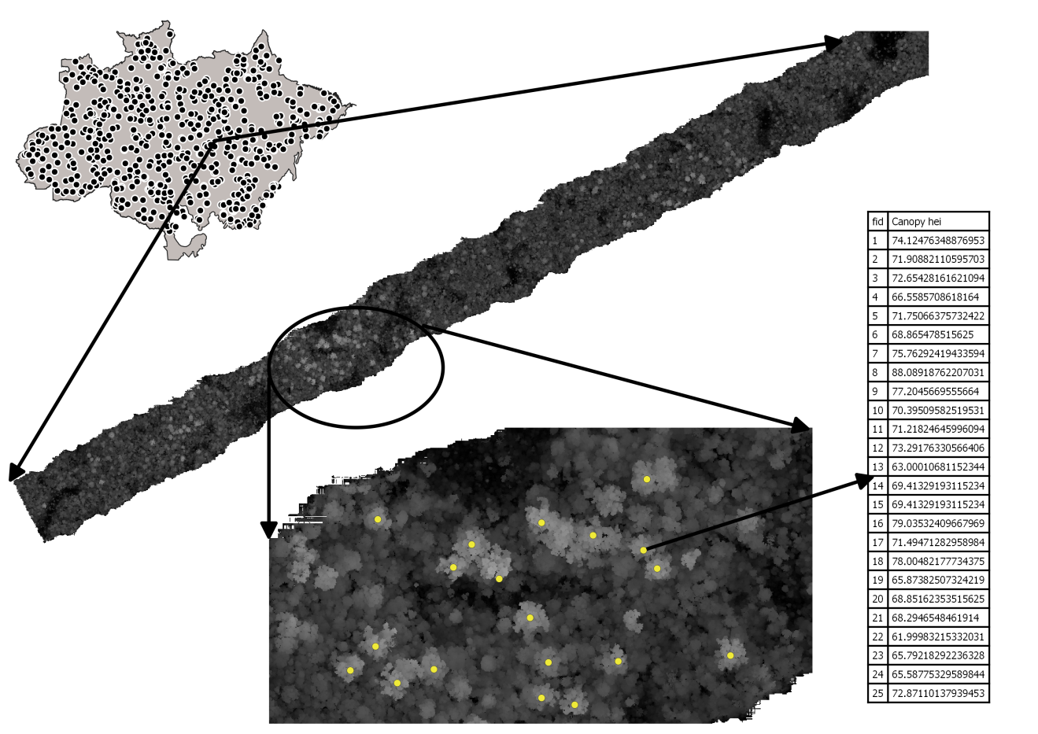

Supplementary Figure 1. The uppermost vegetation heights were employed to compute a canopy height model CHM for each transects. Based on a local maximm filter, the tallest trees of each transects was located, and the tallest individual was identified and isolated to represent each transect.

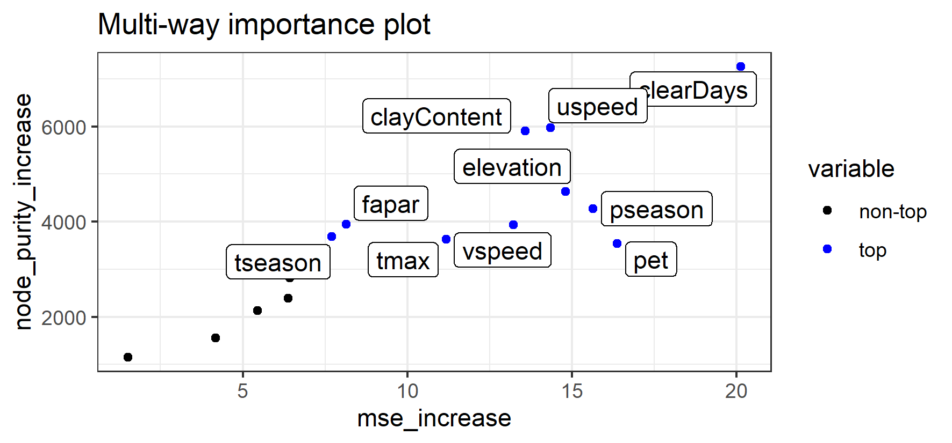

Supplementary Figure 2. Variable importance considering the mean increase in accuracy (mse_increase) and the mean increase in node purity (node_purity_increase).

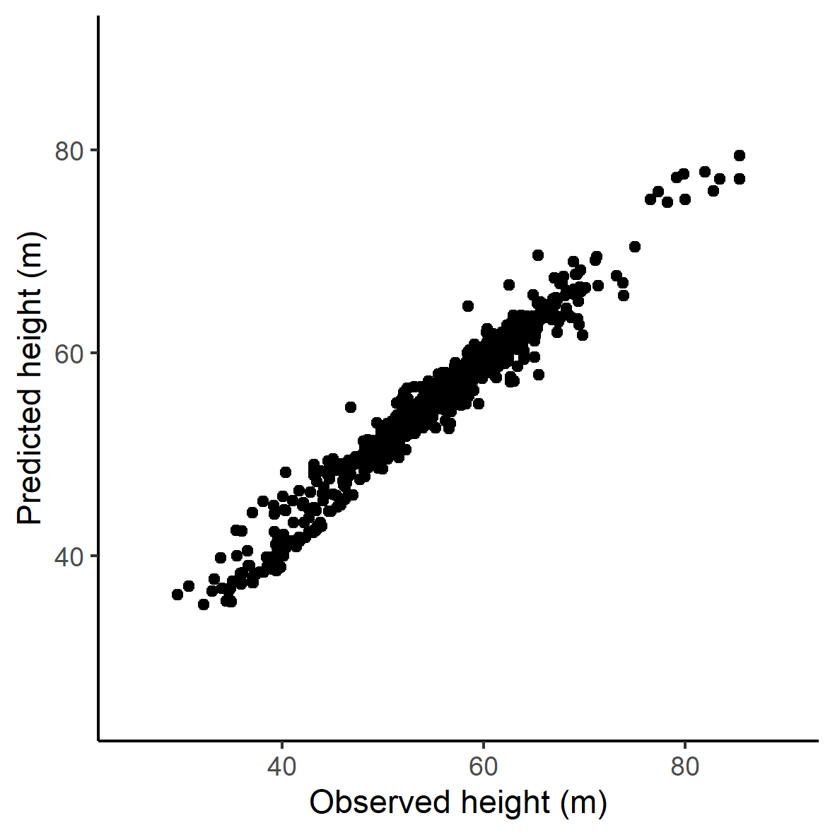

Supplementary Figure 3. Observed versus predicted maximum height by the Random Forest model.

Supplementary Table 1. Variable importance results for the Random Forest model adjusted considering all the transects, and removing transects located in secondary and degraded forests (i.e. intact forest).

|  |  |  |
| --- | --- | --- |
| Layer | Importance including all transects  (increase accuracy) | Importance excluding secondary and degraded forest  (increase accuracy) |
| clearDays | 25.5 | 22.5 |
| clayContent | 23.4 | 21.8 |
| topography | 23.3 | 20.9 |
| pannual | 22.4 | 21.4 |
| pseason | 21.3 | 19.3 |
| tseason | 21.3 | 19.4 |
| uspeed | 21.1 | 18.4 |
| pet | 20.2 | 17.4 |
| fapar | 20.0 | 17.3 |
| pwettest | 19.9 | 18.3 |
| tmax | 19.8 | 18.9 |
| vspeed | 18.1 | 18.4 |
| lightning | 18.0 | 17.2 |
| days20 | 16.4 | 18.9 |
| tannual | 15.6 | 15.3 |
| waterContent | 9.7 | 9.6 |